**Risk Management In class exercise:**  
  
Hello All,   
  
PFA,  
  
Here are my attachments of the class work which I had done regarding openvas installation, and user creation command and whoami command as a root who worked to install and created user for the login of the green board security Assistant.   
  
  
Login url is :   
  
<https://sunshine.edu:9392/login/login.html>

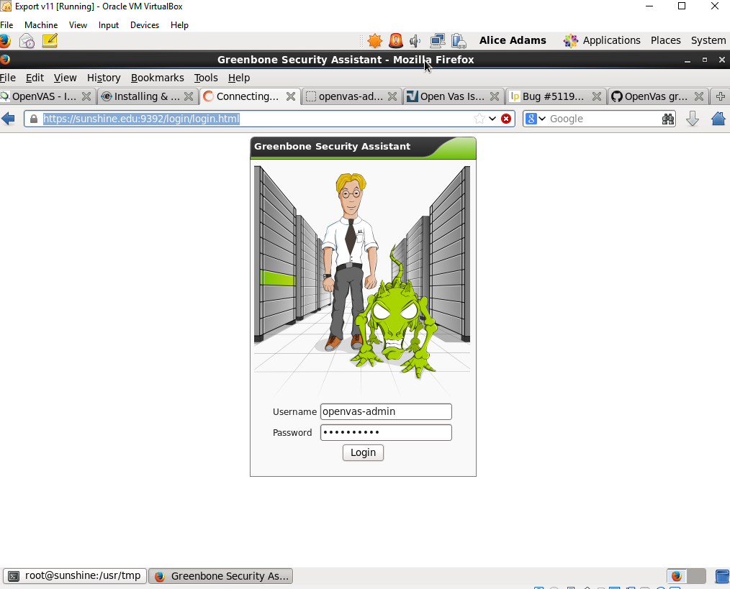  
  
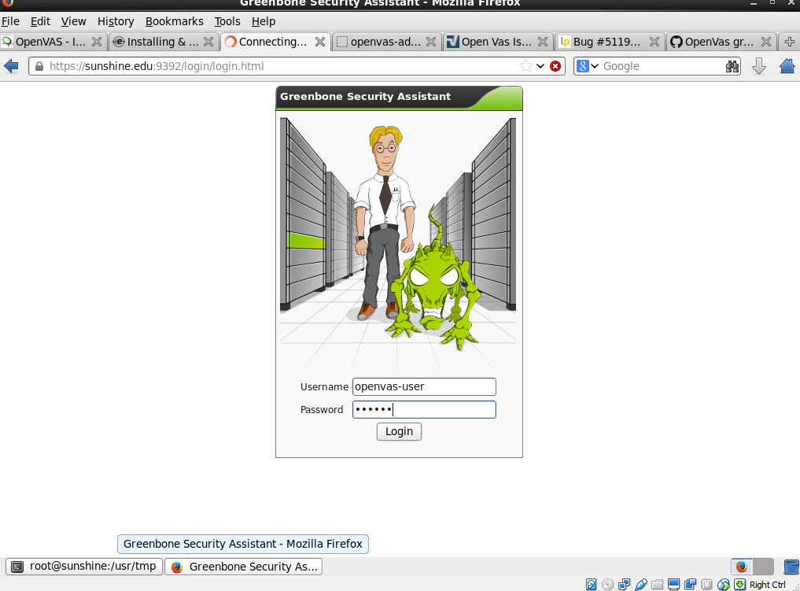  
  
  
  
Command for creating the user:  
  
  
  
  
W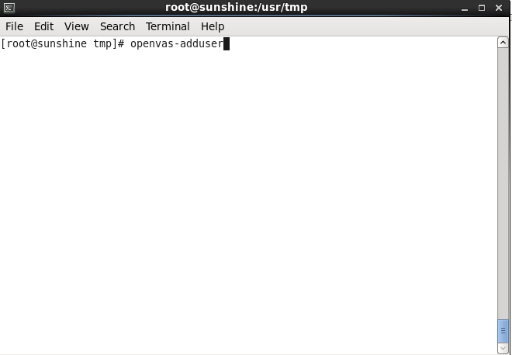  
  
  
Whoami:  
  
  
